KIẾN THỨC WRITING PRE FOUNDATION

CẤU TRÚC MIÊU TẢ TĂNG GIẢM
- X + V + ADV.
- The number of female leaders increased significantly.

- There was a/an + A + N + in + X.
- There was a significant increase in the number of female leaders in 2010.

- X + saw/witnessed/experienced + a/an + A + N.
- The number of female leaders witnessed a significant increase in 2010.

- A/an + A + N + was + seen/witnessed/experienced + in X.
- A significant increase was witnessed in the number of female leaders in 2010.

- The year +…+ saw/witnessed + a/an + A + N + in X.
- The year 2010 witnessed a significant increase in the number of female leaders.

- Chú ý giới từ chỉ data
- Tăng/ giảm tới mức: N/V + to + data
- Tăng/giảm 1 khoảng: V + by + data
N + of + data

CẤU TRÚC SO SÁNH
Cấu trúc chung: [tính chất] + [data]
- X1 + tobe/stand at + [data], …… times + /as much(many) as/lower than/higher than/ + X2.
- The number of female leaders stood at 100, three times as many as that of male leaders.

- X1 + tobe/stand at + [data], double/triple X2.
- The number of female leaders was 100, triple that of male leaders.

- X1 + tobe/stand at + [data], compared to/ in comparison with + [data] + for/of X2.
- The number of female leaders stood at 100, compared to 33 for male leaders.

- X1 was + …… times + /as much(many) as/lower than/higher than/ + X2, at + [data].
- The number of female leaders was three times as many as that of male leaders, at 100.

- At [data], X1 was + …… times /as much(many) as/lower than/higher than/ X2.
- At 100, the number of female leaders was three times as many as that of male leaders.
- Chú ý: nên tập trung sử dụng cấu trúc in vàng

MỆNH ĐỀ QUAN HỆ RÚT GỌN

 | Cấu trúc | Ví dụ
CHỦ ĐỘNG | GỐC:  The number/amount/percentage/… of + N + which/who/that + V (chia như bình thường theo thì của câu) | The number of workers who retired…..;  The percentage of students who graduated…
 | RÚT GỌN:  The number/amount/percentage/… of + N + V-ing | The number of workers retiring…..;  The percentage of students graduating…;
BỊ ĐỘNG | GỐC:  The number/amount/percentage/… of + N + which/who/that + TOBE + V3  (TOBE chia như bình thường theo thì của câu) | The amount of milk which was produced…  The proportion of students who were accepted to this school…
 | RÚT GỌN:  The number/amount/percentage/… of + N + V3 | The amount of milk produced…  The proportion of students accepted to this school…

INTRODUCTION & OVERVIEW

Introduction
- The graph/chart/table below => The given line graph/bar chart/table…
- the number/amount of => how many/much + S + V (chọn một động từ phù hợp, đôi khi phải tự sáng tạo)
- The percentage => the proportion hoặc ngược lại
- In three different places => in + tên từng nơi
- Chú ý nên linh hoạt, đề làm thế nào thì mình sẽ làm cách khác đề
- EXAMPLE:
ĐỀ | INTRODUCTION
The line graph below shows the percentage of tourists to Scotland who visited 4 different attractions from 1980 to 2010 | The given line graph illustrates the percentage of visitors to four places in Scotland, including aquarium, castle, zoo, and festival between 1980 and 2010
The graph below shows the number of boys and girls playing sports in an English town in 2012. | The given line graph compares how many boys and girls enjoyed six different types of sports in England in 2012.

Overview:
- Có xu hướng (có thời gian – biểu đồ động)
- Câu 1: mô tả trend (cái nào tăng? Cái nào giảm? => so sánh điểm đầu và điểm cuối)
- Áp dụng cấu trúc miêu tả tăng giảm
- Chú ý cụm từ: “while the opposite was true for….”
- Câu 2: mô tả cái cao nhất hoặc thấp nhất.
  - Nếu có sự thay đổi về category cao nhất theo thời kỳ, có thể áp dụng cấu trúc:
  - [time], X1 was the most/popular/common/the highest…..; however, it was surpassed by X2.
- EXAMPLE:
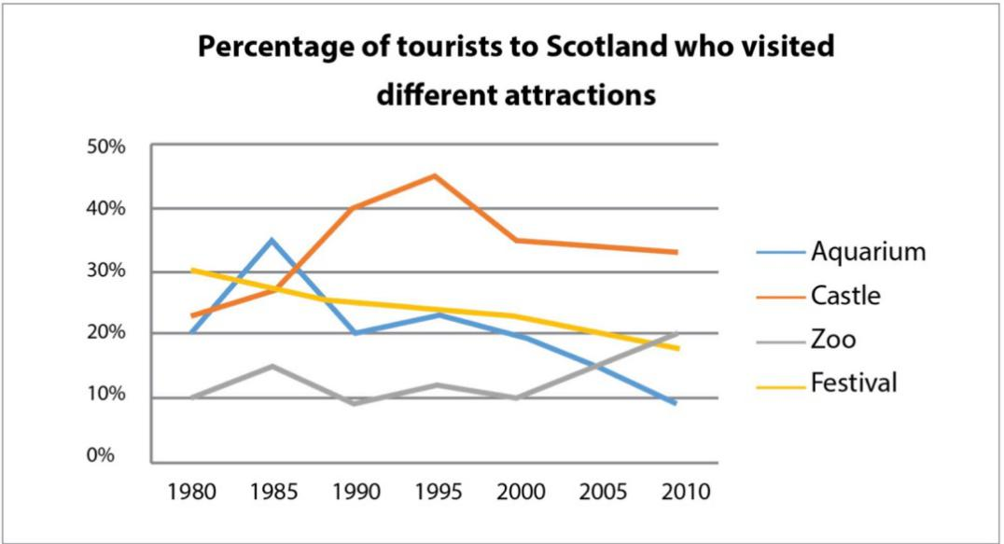

- Câu 1: mô tả trend
Overall, there was a growth in the percentage of tourists visiting castles and zoos, while the opposite was true for aquariums and festivals.
- Câu 2: mô tả cái cao nhất hoặc thấp nhất.
Also, castles were the most popular attractions for most of the period concerned.

- Không có xu hướng (không có thời gian – biểu đồ tĩnh)
- Câu 1: tả cái cao nhất
- Câu 2: tả cái thấp nhất
- EXAMPLE:

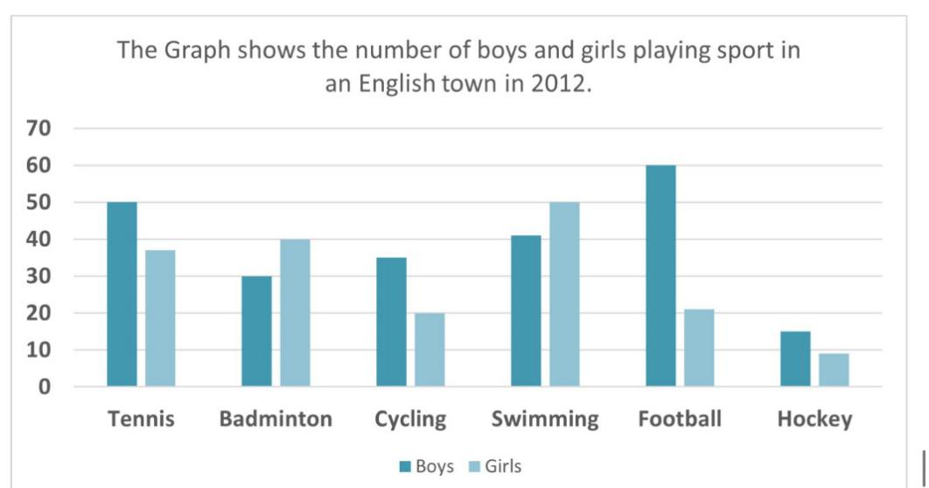

- Câu 1: tả cái cao nhất
It is clear that football was the most popular among boys while girls were most keen on swimming.
- Câu 2: tả cái thấp nhất
In addition, hockey attracted the least number of players, regardless of gender.

